A

Mini-Project Report on

**NUTRINO AI:**

**A HYBRID RECOMMENDATION SYSTEM**

Submitted in partial fulfilment of the requirements for the

degree of

BACHELOR OF ENGINEERING

IN

## Computer Science & Engineering

## Artificial Intelligence & Machine Learning

By

Aafreen Khan (22106048)

Prachiti Parab (22106030)

Sneha Gupta (22106046)

Tulsi Dubey (22106055)

Under the guidance of

# Prof. Taruna Sharma



**Department of Computer Science & Engineering**

**(Artificial Intelligence & Machine Learning)**

## A. P. Shah Institute of Technology G. B. Road, Kasarvadavali, Thane (W)-400615

## University of Mumbai 2024-2025



**A. P. SHAH INSTITUTE OF TECHNOLOGY, THANE**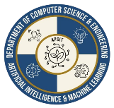

**CERTIFICATE**

This is to certify that the project entitled **“NUTRINO AI : A HYBRID RECOMMENDATION SYSTEM’’** is a bonafide work of Aafreen Khan(22106048), Prachiti Parab(22106030), Sneha Gupta(22106046), Tulsi Dubey(22106055) submitted to the University of Mumbai in partial fulfilment of the requirement for the award of **Bachelor of Engineering** in **Computer Science & Engineering (Artificial Intelligence & Machine Learning).**

|  |  |
| --- | --- |
| ________________ | _______________ |
| Prof. Taruna Sharma | Dr. Jaya Gupta |
| Mini Project Guide | Head of Department |



# A. P. SHAH INSTITUTE OFTECHNOLOGY

**Project Report Approval**

This Mini project report entitled “**NUTRINO AI: A HYBRID RECOMMENDATION SYSTEM*”*** by **Aafreen khan, Prachiti Parab, Sneha Gupta, Tulsi Dubey** is approved for the degree of ***Bachelor of Engineering*** in ***Computer Science &Engineering***, (AIML) ***2024-25***.

External Examiner:

Internal Examiner:

Place: APSIT, Thane

Date:

## Declaration

We declare that this written submission represents my ideas in my own words and where others' ideas or words have been included, I have adequately cited and referenced the original sources. I also declare that I have adhered to all principles of academic honesty and integrity and have not misrepresented or fabricated or falsified any idea/data/fact/source in my submission. I understand that any violation of the above will be cause for disciplinary action by the Institute and can also evoke penal action from the sources which have thus not been properly cited or from whom proper permission has not been taken when needed.

Aafreen Khan Prachiti Parab Sneha Gupta Tulsi Dubey

(22106048) (22106030) (22106046) (22106055)

## ABSTRACT

Nutrino AI is a hybrid recommendation system designed to provide personalized nutrition guidance by integrating content-based and user based filtering techniques. The system includes a BMI calculator that takes user inputs such as height, weight, and age to determine their BMI category (Underweight, Normal, Overweight, or Obese). Based on this classification, it recommends customized meal plans and recipes that align with the user's health goals and dietary needs. The system analyzes user data, including dietary preferences, health conditions, and lifestyle factors, to generate tailored meal and nutrition recommendations. By leveraging a hybrid approach, Nutrino AI aims to enhance accuracy, diversity, and relevance in dietary suggestions while addressing the limitations of traditional recommendation methods. However, challenges such as data quality, real-time personalization, privacy concerns, and scalability must be carefully managed. This system has the potential to revolutionize personalized nutrition by offering adaptive and trustworthy dietary guidance, improving user engagement and health outcomes.

**INDEX**

|  |  |  |  |
| --- | --- | --- | --- |
| Index | | | Page no. |
| Chapter-1 | | |  |
|  | Introduction | | 1-4 |
| Chapter-2 | | |  |
|  | Literature Survey | | 5-7 |
|  | 2.1 | History | 5 |
|  | 2.2 | Review | 6-7 |
| Chapter-3 | | |  |
|  | Problem Statement | | 8-9 |
| Chapter-4 | | |  |
|  | Experimental Setup | | 10-11 |
|  | 4.1 | Hardware setup |  |
|  | 4.2 | Software Setup |  |
| Chapter-5 | | |  |
|  | Proposed system and Implementation | | 13-18 |
|  | 5.1 | Block Diagram of proposed system | 14 |
|  | 5.2 | Description of Block diagram | 15-16 |
|  | 5.3 | Implementation | 17-18 |
| Chapter-6 | | | 19-20 |
|  | Conclusion | |  |
| References | | | 21 |

# 

# CHAPTER 1

# INTRODUCTION

# 

# 1

## 1.INTRODUCTION

In the modern era, maintaining a healthy and balanced diet is essential for overall well-being. However, individuals often face challenges in selecting meals that align with their dietary preferences, health conditions, and fitness goals. Traditional nutrition recommendation systems primarily rely on either content-based filtering, which suggests items based on user preferences, or collaborative filtering, which recommends items based on similar users’ choices. While these methods have their advantages, they also suffer from limitations such as lack of personalization, cold-start problems, and an inability to adapt to changing user needs.

To address these challenges, Nutrino AI introduces a hybrid recommendation system that combines both content-based and collaborative filtering approaches to provide highly personalized and adaptive meal suggestions. A key feature of this system is the integration of a Body Mass Index (BMI) calculator, which categorizes users based on their BMI (Underweight, Normal, Overweight, or Obese) and recommends customized meal plans accordingly. This ensures that users receive diet recommendations tailored to their specific health requirements, promoting better nutritional choices and overall wellness.

The proposed system collects user inputs such as age, weight, height, dietary habits, and medical conditions to generate meal suggestions that align with their nutritional needs. By leveraging AI-driven insights, Nutrino AI enhances the accuracy, diversity, and relevance of dietary recommendations. Furthermore, the system continuously learns from user interactions, improving its recommendations over time.

Despite its advantages, the implementation of a hybrid recommendation system in the field of nutrition comes with challenges. Issues related to data quality, scalability, privacy concerns, and real-time adaptability must be addressed to ensure optimal performance and user trust. However, with the rapid advancement of artificial intelligence and machine learning, Nutrino AI has the potential to revolutionize personalized nutrition by providing intelligent, data-driven dietary recommendations that cater to individual needs.

Nutrino AI as a hybrid recommendation system. It discusses the underlying algorithms, the role of the BMI calculator in meal planning, and the challenges associated with personalized nutrition recommendations. Through this study, we aim to demonstrate how AI-powered solutions can significantly enhance dietary planning, leading to improved health outcomes for users.

**2**

**The key features include:**

**1. Hybrid Recommendation System**

* Combines **content-based filtering** (analyzing user preferences) and **user-based filtering** (provide recipes from user input and preferences) for more accurate recommendations.
* Reduces cold-start problems and improves personalization.

**2. BMI Calculator**

* Takes user inputs (height, weight, age, gender) to calculate **Body Mass Index (BMI)**.
* Categorizes users into **Underweight, Normal, Overweight, or Obese**.
* Provides meal recommendations based on BMI category.

**3. Personalized Meal & Recipe Suggestions**

* Generates customized meal plans considering dietary preferences, allergies, and health conditions (e.g., diabetes, hypertension).
* Suggests **nutrient-rich recipes** that align with user fitness goals (weight loss, muscle gain, etc.).

**4. Nutritional Analysis**

* Breaks down recommended meals into **calories, macronutrients (carbs, proteins, fats), and micronutrients (vitamins, minerals)**.
* Helps users track their daily nutrient intake.

**5. User Profile**

* Stores user health data, dietary history, and fitness goals.
* Provides **progress tracking** with insights on weight management and nutrition trends.

**3**

# CHAPTER 2

**LITERATURE SURVEY**

**4**

**2.LITERATURE SURVEY**

### 2.1 -HISTORY

The development of **Nutrino AI**, a hybrid recommendation system for personalized nutrition, is rooted in the evolution of artificial intelligence (AI) and dietary planning technologies. The history of AI-driven nutrition systems dates back to the 1990s when early recommendation models were primarily **rule-based expert systems**. These systems followed predefined dietary rules and guidelines, such as those from the USDA, to suggest general meal plans. However, they lacked personalization, as they did not adapt to individual preferences, health conditions, or changing dietary habits.

As AI and machine learning evolved in the early 2000s, **data-driven models** began to play a significant role in nutrition recommendation systems. Machine learning techniques allowed for **content-based filtering**, where recommendations were generated based on user preferences, dietary restrictions, and health goals. This approach improved personalization but had limitations, as it struggled to suggest new meal options beyond a user’s existing preferences. Around the same time, **user based filtering** was introduced, enabling nutrition systems to recommend meals based on the eating habits of similar users. While collaborative filtering expanded recommendation diversity, it suffered from issues like the **cold-start problem**, where new users with no prior data received poor or generic recommendations.

The limitations of individual recommendation models led to the emergence of **hybrid recommendation systems** in the 2010s. These systems combined **content-based and user based filtering** techniques to enhance accuracy, personalization, and adaptability. Alongside this, AI-driven nutrition applications started incorporating **real-time health monitoring**, integrating with wearable devices such as Fitbit and Apple Health to track user activity and calorie intake. **BMI-based meal planning** became more prevalent, as researchers recognized that dietary recommendations should be tailored not only to user preferences but also to their **body composition and health metrics**.

Nutrino AI emerged as a hybrid recommendation system that integrates **BMI classification with AI-driven meal planning**. It utilizes **content-based filtering** to analyze user preferences, **collaborative filtering** to enhance recommendation diversity, and a **BMI calculator** to classify users into different weight categories and provide personalized meal suggestions accordingly. This approach ensures that users receive **nutritionally balanced** recommendations that align with their health goals, whether for weight loss, muscle gain, or overall wellness.

**5**

### 2.2 -LITERATURE REVIEW

**1. Early AI-Based Nutrition Systems (1990s–2000s)**

* **Rule-Based Systems**: Early systems used **predefined dietary rules** to suggest meals but lacked adaptability.
* **USDA Dietary Guidelines**: Provided static recommendations but were not personalized.

**2. Evolution of AI in Nutrition (2010s–Present)**

**Content-Based Filtering (2017)**

* + **Elsweiler et al. (2017)** introduced content-based filtering, where meals were recommended based on user preferences.
  + Faced limitations like lack of diversity and inability to suggest new foods outside a user’s existing preferences.

**User-Based Collaborative Filtering (2019)**

* Trattner & Elsweiler (2019) explored user-based collaborative filtering, where recommendations were generated by identifying users with similar dietary preferences and eating habits.
* This approach improved recommendation diversity and helped users discover new meal options based on others with similar tastes.

**Hybrid Recommendation Systems (2005–Present)**

* + **Adomavicius & Tuzhilin (2005)** emphasized the advantages of combining multiple recommendation techniques.
  + **Jin et al. (2019)** demonstrated that hybrid models significantly improve recommendation accuracy, diversity, and personalization.
  + **Wang et al. (2021)** applied hybrid models in nutrition and found them to be more effective than standalone content-based or user based filtering.

**3. BMI-Based Personalized Meal Planning (2019–2020)**

* **Kruk et al. (2019)** analyzed the impact of BMI-based meal recommendations and found that users following BMI-based plans showed improved health outcomes.
* **Ali et al. (2020)** developed an AI-driven BMI-based dietary system that adjusted meal plans based on user weight categories.

**6**

**4. Deep Learning and Real-Time Adaptation in Nutrition (2020s)**

* **Gao et al. (2021)** explored deep learning for food recommendations, improving the accuracy of AI-driven diet suggestions.
* **Liu et al. (2023)** highlighted the importance of **real-time adaptation**, ensuring meal recommendations adjust dynamically based on user behavior.
* **Hsu et al. (2022)** emphasized the need for data privacy in AI-based health applications.

**5. Challenges in AI-Based Nutrition Systems**

* **Data Quality & Availability**: AI models require large, high-quality datasets for better accuracy. Incomplete or inconsistent data affects recommendations (**Hsu et al., 2022**).
* **Privacy & Security Concerns**: Ensuring secure storage and encryption of user health data is critical for user trust (**Gao et al., 2021**).
* **Scalability & Real-Time Learning**: AI nutrition systems must adapt to changing user preferences over time (**Liu et al., 2023**).

**6. Contribution to Hybrid Nutrition Recommendation Systems**

* Integrates **content-based, collaborative filtering, and BMI-based classification** for enhanced personalization.
* Uses **real-time data adaptation**, continuously improving recommendations based on user behavior.
* Focuses on **health-conscious, dynamic meal planning**, ensuring dietary recommendations align with user goals (e.g., weight loss, muscle gain, balanced nutrition).
* Addresses **privacy concerns** by implementing secure data management and compliance with health data regulations.

**7**

# CHAPTER 3

# PROBLEM STATEMENT

# 

# 

# 8

## 3.Problem Statement

In the evolving field of personalized nutrition, users face challenges in finding accurate, tailored dietary recommendations that align with their health goals, preferences, and lifestyle conditions. Existing recommendation systems often rely on either content-based or collaborative filtering methods, but they struggle to fully personalize suggestions, handle diverse user needs, and ensure privacy.

Nutrino AI seeks to address these challenges by developing a hybrid recommendation system that combines both content-based and collaborative filtering techniques, delivering more accurate, diverse, and context-sensitive nutrition advice. However, the system must overcome limitations in data quality, scalability, real-time personalization, privacy concerns, and bias to provide users with relevant, trustworthy, and adaptive dietary recommendations.

**9**

**CHAPTER 4**

**EXPERIMENTAL SETUP**

**10**

**4. EXPERIMENTAL SETUP**

**4.1 Hardware Setup**

* Processor: A modern multi-core processor like Intel Core i5 or AMD Ryzen 5 for efficient AI processing, NLP tasks, and real-time recommendations.
* RAM: At least 8GB RAM for smooth operation. For intensive AI processes, 16GB RAM or more is recommended.
* Storage: SSD with minimum 256GB for fast data access, quick application loading, and storing user interactions. Additional storage may be required for backups and logs.
* Graphics: Integrated graphics are sufficient unless high-end AI visualizations are needed.
* Network: Stable Ethernet or Wi-Fi for seamless real-time data transfer between the user and server.

**4.2 Software Setup**

Operating System: Use Windows 10/11, macOS, or a Linux distribution like Ubuntu/CentOS for compatibility with AI models and backend services.

1. **Frontend**:

* State Management: Redux or Context API
* Styling: Tailwind CSS, Material UI, or Bootstrap
* API Communication: Axios Authentication: Firebase Authentication SDK
* Deployment: Vercel, Netlify, or Firebase HostingBackend & AI Frameworks:

1. **Backend:**

* Framework: FastAPI (Python) for API Gateway and Microservices
* Language: Python 3.10+
* REST API Management: FastAPI with Pydantic for data validation
* Environment Management: Python venv
* Package Management: pip
* Middleware: CORS Middleware
* Testing: Postman
* Deployment: Google Cloud FunctionsNetworking & Security

# 11

# 3. Authentication Service

# Service Provider: Firebase Authentication

# Authentication Methods: Email/Password, Google, Apple Sign-in

# Token Management: JWT Tokens

# SDK Integration: Firebase Admin SDK for backend verification

# Data Protection: Encrypted storage using AES-256 for sensitive data

# 4. Recommendation Engine

# Algorithm Implementation:

# User based Collaborative Filtering

# Content-Based Filtering

# Hybrid Approach using custom Python logic

# AI Service Integration: OpenAI API for generating personalized recipes

# Caching: Redis for fast recommendation retrieval

# 5. Database Management

# Database Type: NoSQL

# Service Provider: Firestore (Managed Database)

# Users: Stores user data, preferences, and history

# Recipes: Pre-defined and AI-generated recipes

# Real-Time Updates: Firestore's real-time listeners for instant UI updates

# 12

# CHAPTER 5

**PROPOSED SYSTEM**

**& IMPLEMENTATION**

**13**

## PROPOSED SYSTEM & IMPLEMENTATION

### 5.1 Block diagram of proposed system

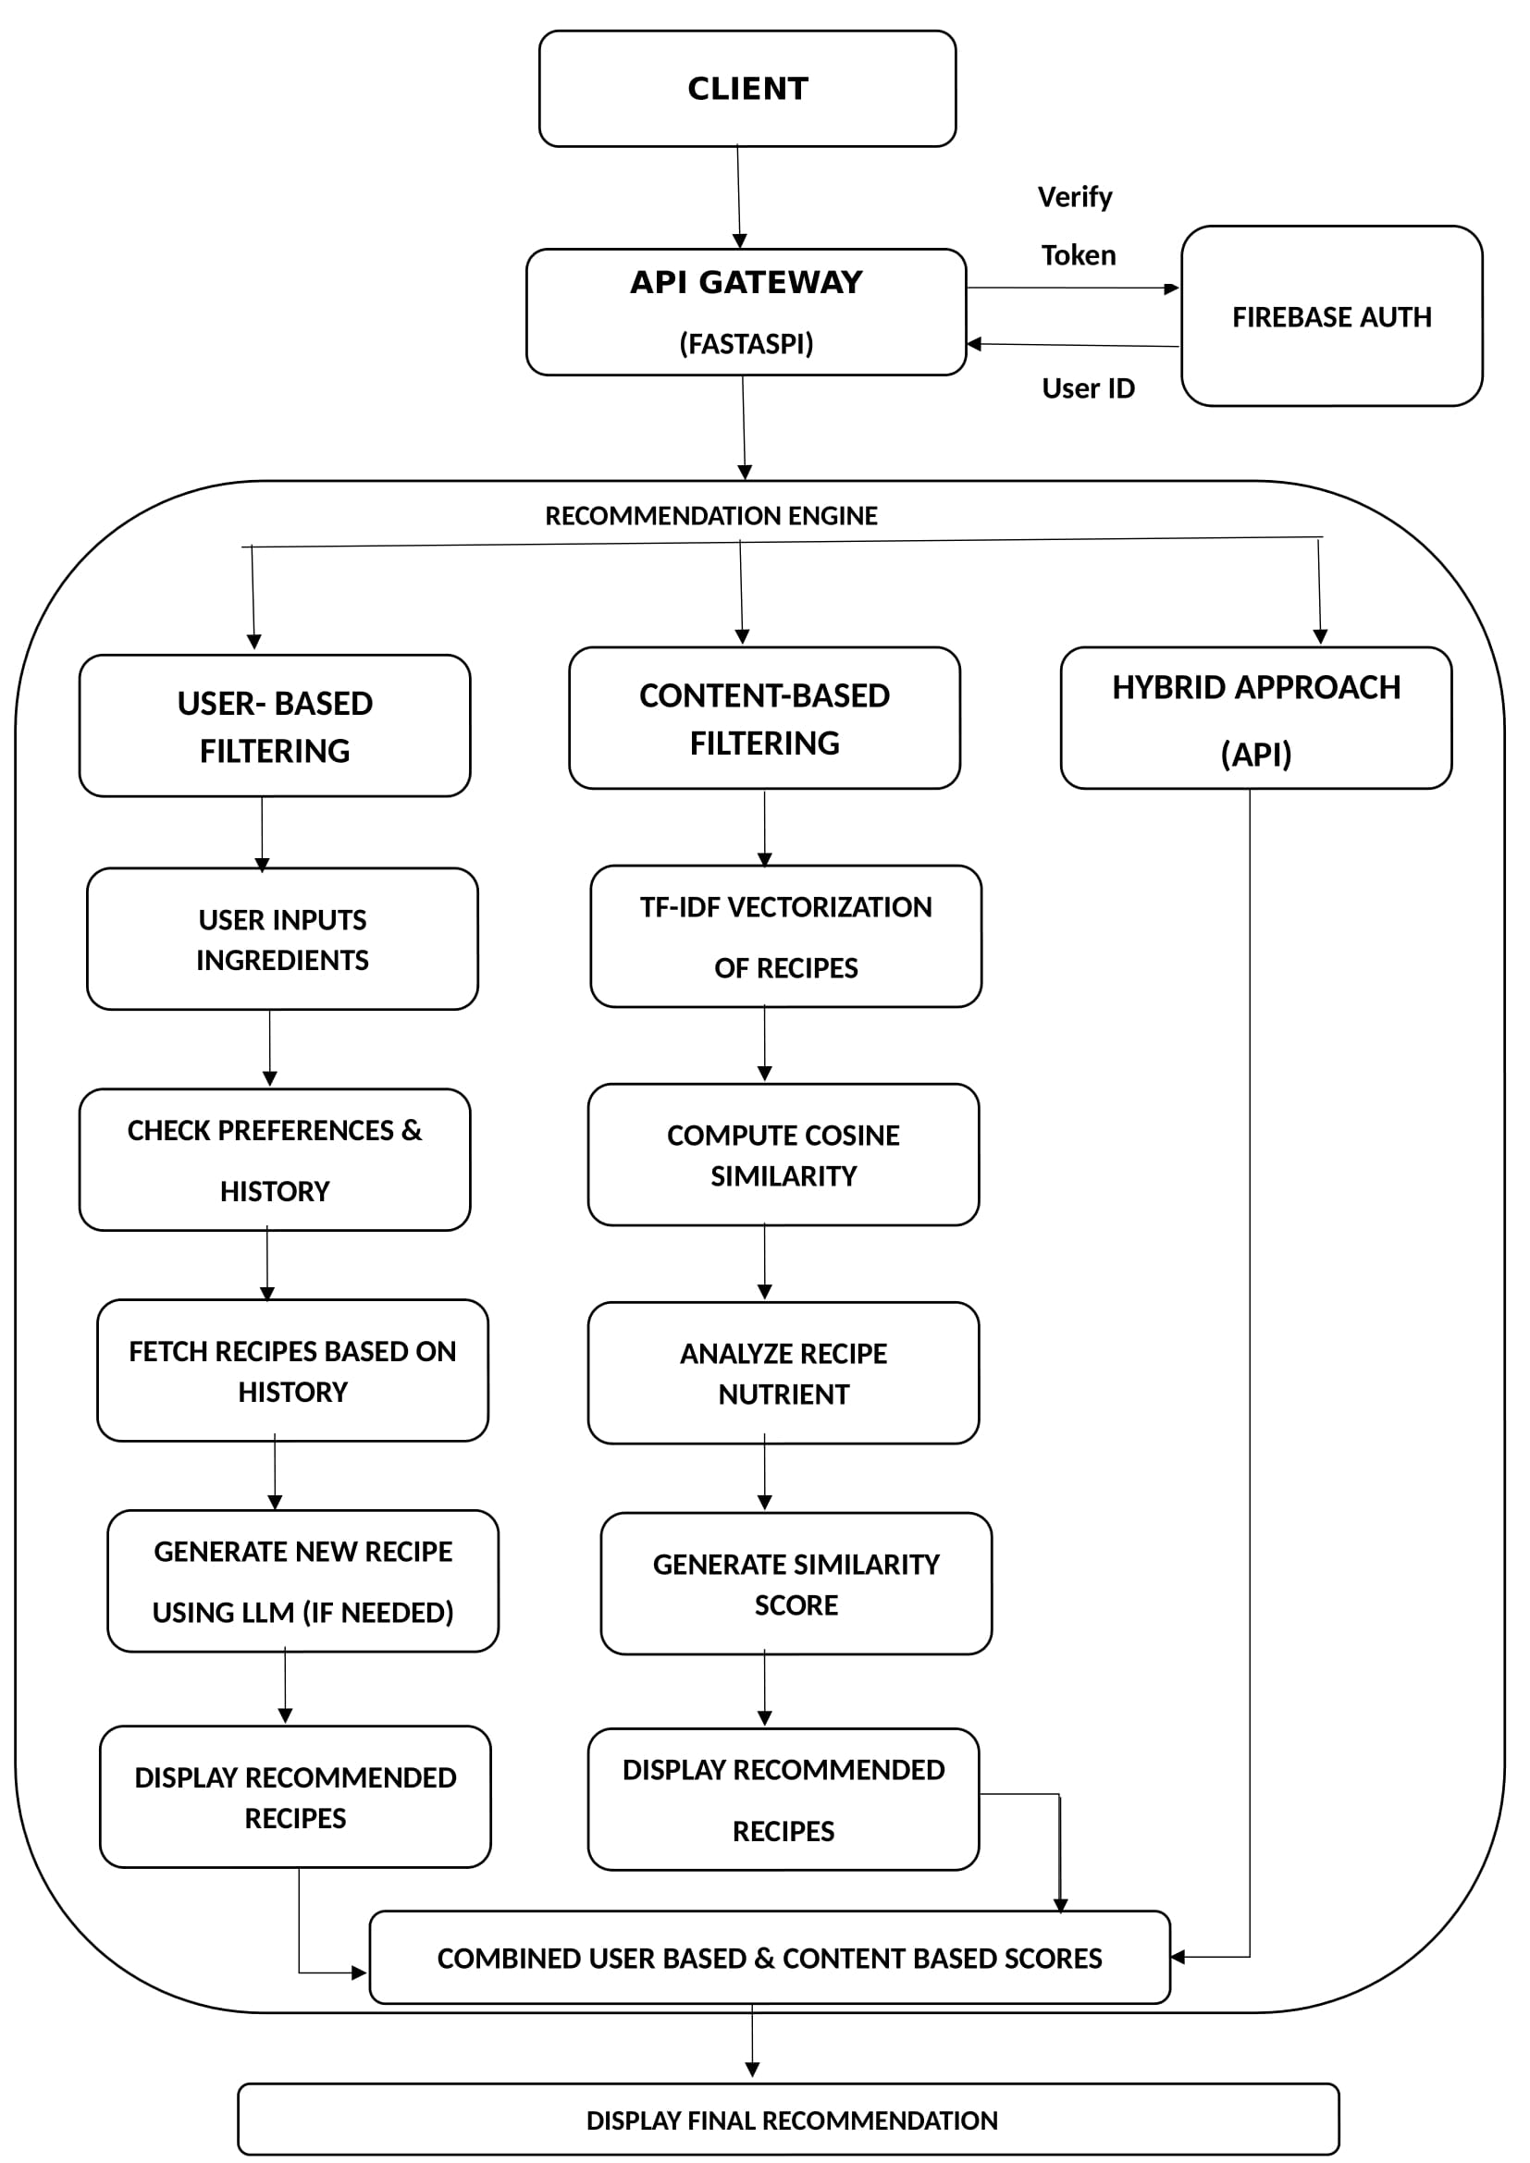

**Fig 1.1 System Design**

**14**

### 5.2 Description of block diagram

### 

### This system design diagram illustrates the architecture of a Hybrid Recipe Recommendation System that combines user preferences with ingredient-based recipe matching and AI-powered recipe generation. The system follows a modular design pattern with clear separation of concerns between authentication, recommendation logic, data storage, and external service integration.

### Architecture Components

### 1. Client Layer

### The topmost component represents the user-facing applications (web and mobile interfaces) where users input ingredients and interact with the recommendation system. This layer communicates with the backend via HTTP POST requests to the recommendation endpoint, sending both ingredients and authentication tokens.

### 2. API Gateway

### Built using FastAPI, this component serves as the central entry point for all client requests. It handles Cross-Origin Resource Sharing (CORS), manages asynchronous requests, and routes traffic to appropriate services. The API Gateway processes incoming user data and coordinates the authentication and recommendation workflows.

### 3. Authentication Service

### Implemented using Firebase Auth, this external service verifies user identity tokens and returns validated user IDs to the API Gateway. This ensures that recommendations can be personalized and that only authenticated users can access the system.

### 4. Recommendation Engine

### The core of the system consists of two specialized modules:

### - User-Based Recommender: Focuses on personalization by analyzing user history and preferences

### - Recipe Recommender: Handles ingredient matching and coordinates with the external AI service for recipe generation

### This hybrid approach combines collaborative filtering techniques with content-based recommendation methods to produce highly relevant results.

### 15

### 5. External AI Service

### The system integrates with OpenAI API to dynamically generate new recipes based on available ingredients and dietary requirements like calorie counts. This service extends the system's capabilities beyond pre-existing recipes in the database.

### 6. Database Layer

### Using Firestore as a NoSQL database solution, the system maintains two primary collections:

### - Users Collection: Stores user profiles, preferences, dietary restrictions, and interaction history

### - Recipes Collection: Contains both pre-defined recipes and dynamically generated ones

### 7. Logging Module

### This component captures system events from all other modules for monitoring, debugging, and analytics purposes. The dashed connections indicate the non-blocking nature of the logging operations.

### Data Flow

### 1. The client sends ingredient lists and authentication tokens to the API Gateway

### 2. The API Gateway verifies user identity through Firebase Auth

### 3. Once authenticated, the request is forwarded to the Recommendation Engine

### 4. The User-Based Recommender retrieves user history and preferences from the database

### 5. The Recipe Recommender matches ingredients against existing recipes and requests new recipe generation when needed

### 6. If required, the OpenAI API generates new recipes that are then stored in the Recipes Collection

### 7. The Recommendation Engine ranks and compiles the final recommendations

### 8. Results are returned to the client via the API Gateway as a JSON response containing recipes and metadata

### This architecture balances performance, flexibility, and user experience while enabling both traditional recipe recommendations and AI-generated custom recipes based on available ingredients.

### 16

**5.3 Implementation**

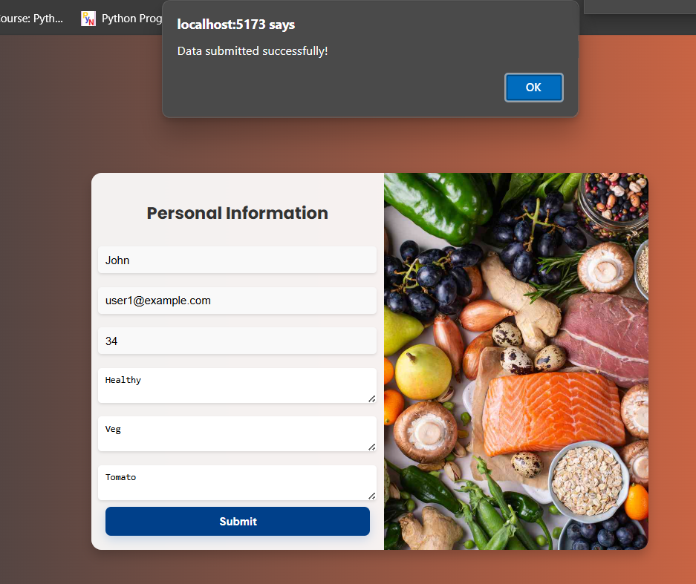

**Fig 2.1 Home Page**

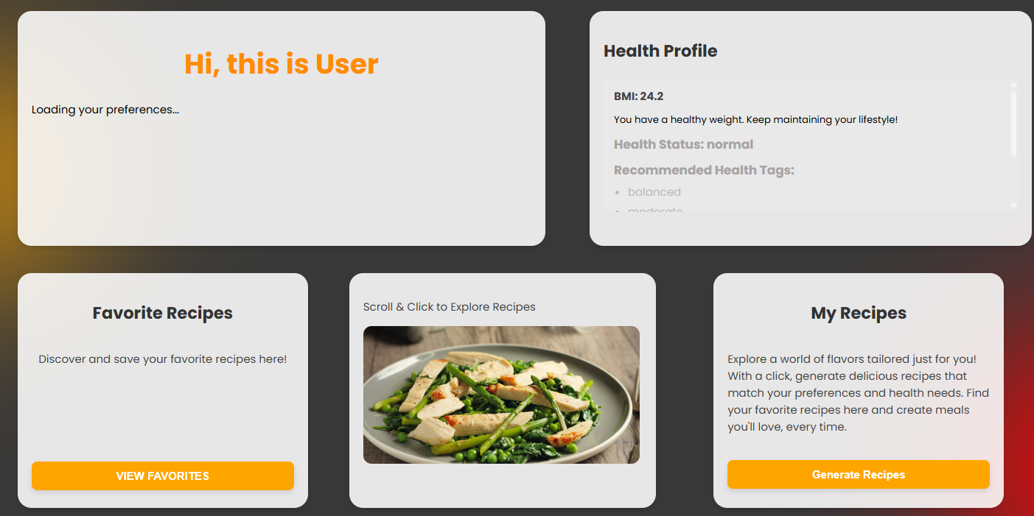

**Fig 2.2 Dashboard**

**17**

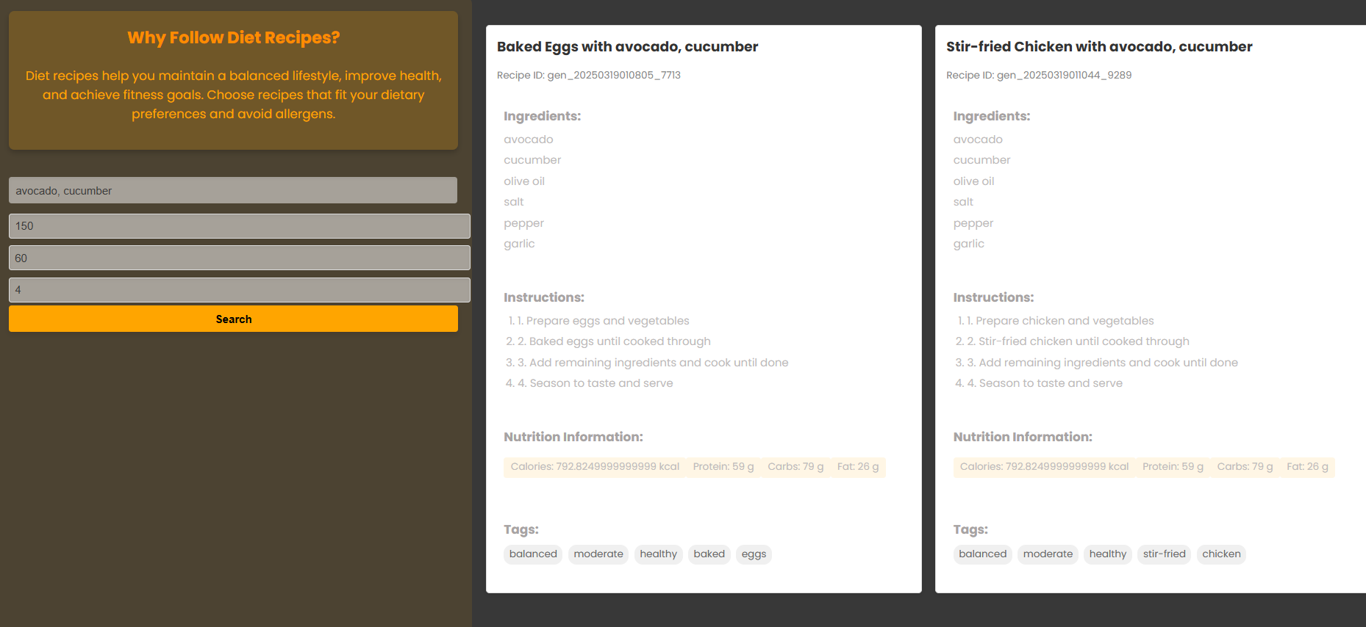

**Fig 2.3 Recipe Generator**

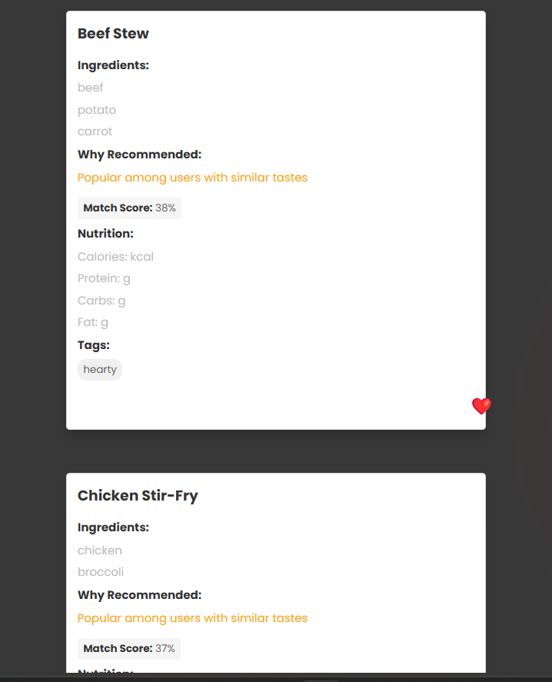

**Fig 2.4 Recommendation Page**

**18**

# 

# CHAPTER 6

# CONCLUSION

# 19

## 6.CONCLUSION

Nutrino AI: A Hybrid Recommendation System highlights its effectiveness in providing personalized nutrition recommendations by combining user-based and content-based filtering to provide personalized and nutritionally optimized recipe recommendations by leveraging user preferences, dietary needs, and health goals, Nutrino AI enhances recommendation accuracy and user satisfaction. By using TF-IDF, cosine similarity, and user preferences, it ensures relevant suggestions. If no suitable recipes are found, an LLM generates new ones. The hybrid approach enhances accuracy, making it ideal for users with dietary needs and evolving food preferences. Overall, Nutrino AI is an intelligent and efficient food recommendation system.

**20**

## REFERENCES

[1] "Hybrid-Based Food Recommender System Utilizing KNN and SVD" Zhi-Toung Yap, Su-Cheng Haw This study discusses the combination of various algorithms, including collaborative filtering, content-based filtering, and hybrid approaches, in the context of a food recommender system. It was published in the journal *Cogent Engineering* on December 3, 2024.

[2] Hybrid Recommender Systems: A Systematic Literature ReviewErion C¸ ano1, Maurizio Morisio in the journal *Intelligent Data Analysis*, Volume 21, Issue 6, in 2017, spanning pages 1487 to 1524

[3] "A Hybrid Recommender System Based on User-Recommender Interaction" was authored by Heng-Ru Zhang, Fan Min, Xu He, and Yuan-Yuan Xu. It was published in the journal *Mathematical Problems in Engineering* in 2015. The article spans pages 1 to 11.

[4] [4]Wang et al**.** (2022). *Hybrid Recommendation System for E-commerce Using Deep Learning and Collaborative Filtering.* Journal of Artificial Intelligence Research

**21**